Concordia University

Laboratory Report

COEN - 316

Lab – 2

Register File

Submission Date: October 24, 2019

Prepared by

Salman Rahman 27853815

Name Student ID

“I certify that this submission is my original work and meets the Faculty's Expectations of Originality”

Contents

Figures 2

• ModelSim Simulation of Register file: (please zoom in the figures if required) 3

• RTL schematic and Tech schematic 8

• ALU.UCF file 10

• VHDL Code 11

# Figures

Figure 1 Simulation of register file from 0 to 16 ns according to the given do file in the lab manual, in this case the register file was reset using the asynchronous reset signal and different registers are being loaded with the data from the din input signal 3

Figure 2 Simulation of register file from 16 to 38 ns, during this time every register is being saved with data at every clock cycle 3

Figure 3 Simulation of register file from 38 to 82ns, during this time registers up to register 16 in the register file was loaded with data from the din input at every rising clock edge 4

Figure 4 Simulation of register file from 82 to 126ns, during this time registers up to register 27 in the register file was loaded with data from the din input at every rising clock edge 4

Figure 5 Simulation of 126 to 172ns is shown in the figure. All the 32 registers are loaded with data at 32 clock rising edges. The read_a and read_b values are changed to see the proper output at the out ports. 5

Figure 6 RTL schematic of the vhdl code 8

Figure 7 Tech schematic of the synthesis 9

* ModelSim Simulation of Register file: (please zoom in the figures if required)

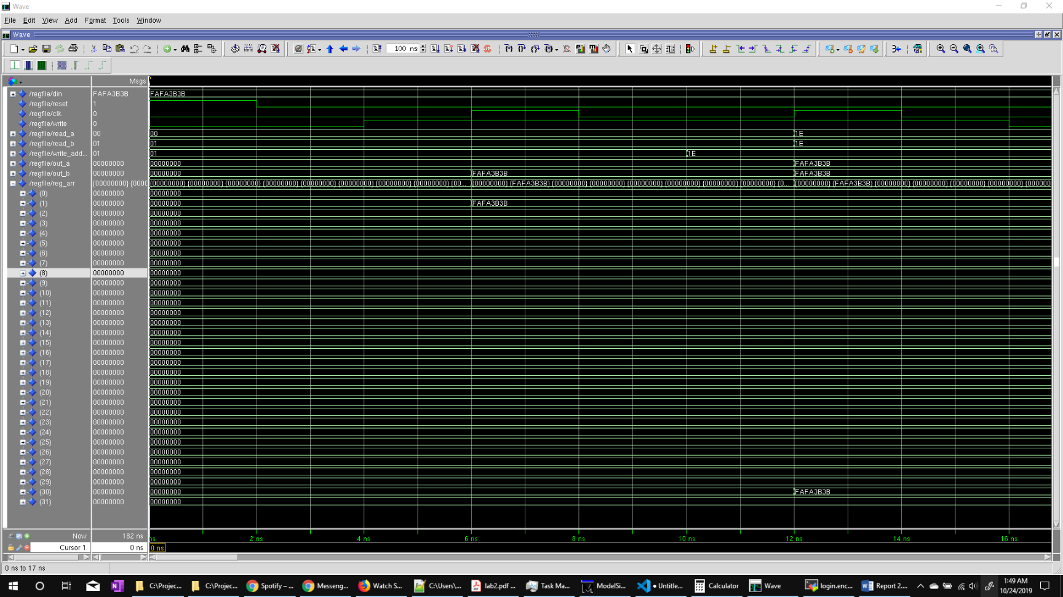

Figure Simulation of register file from 0 to 16 ns according to the given do file in the lab manual, in this case the register file was reset using the asynchronous reset signal and different registers are being loaded with the data from the din input signal

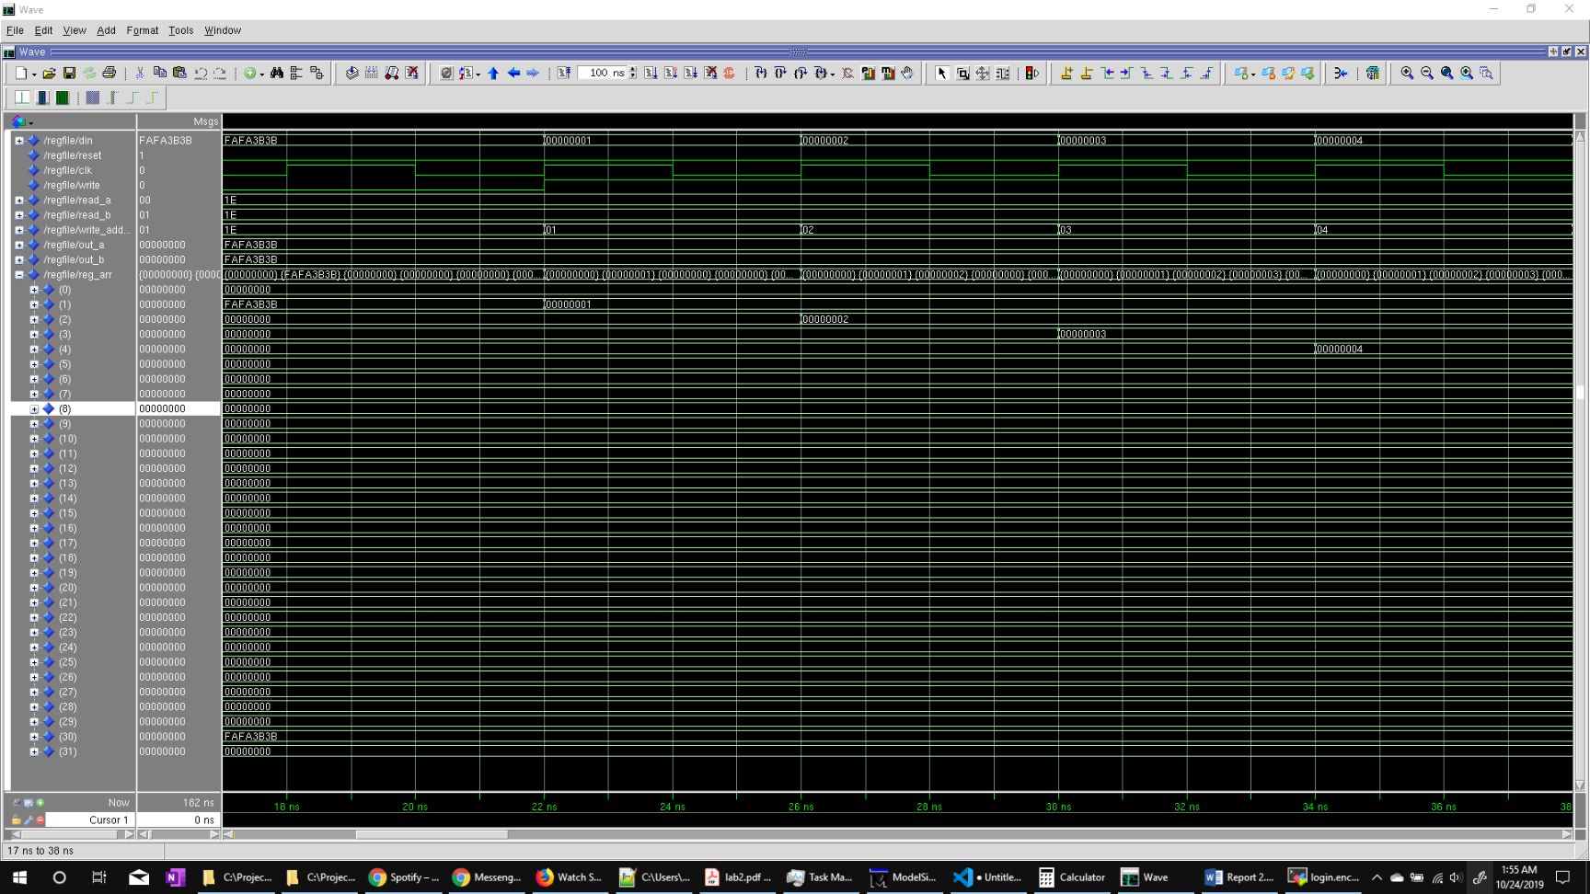

Figure Simulation of register file from 16 to 38 ns, during this time every register is being saved with data at every clock cycle

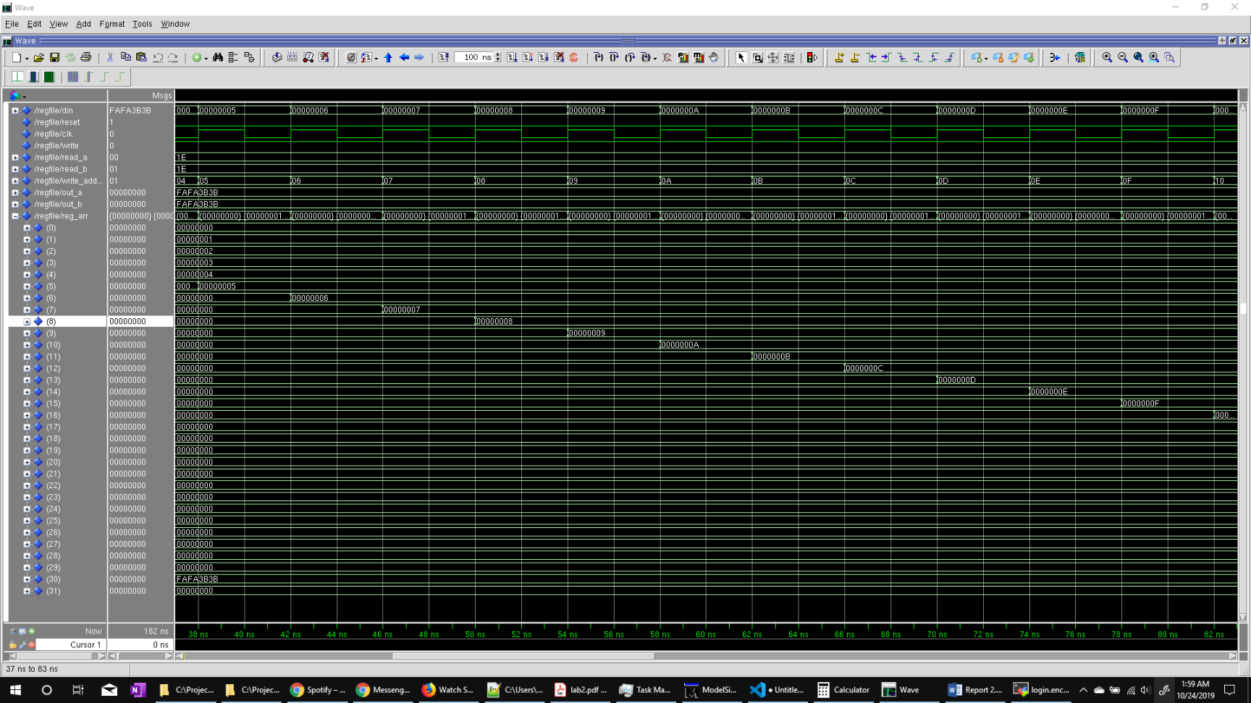

Figure Simulation of register file from 38 to 82ns, during this time registers up to register 16 in the register file was loaded with data from the din input at every rising clock edge

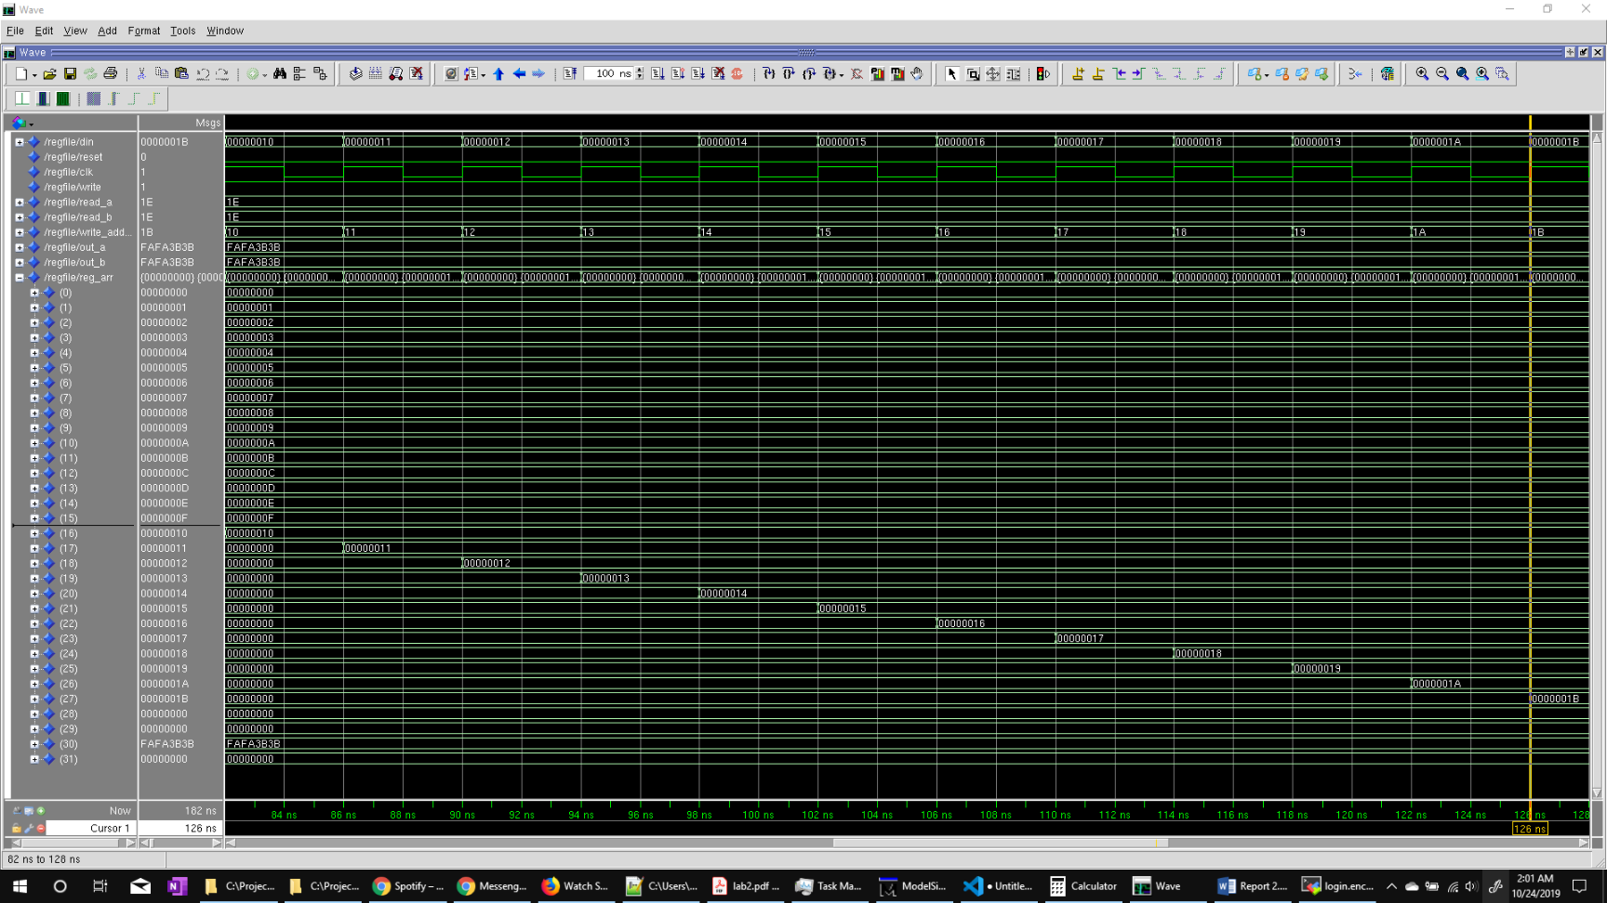

Figure Simulation of register file from 82 to 126ns, during this time registers up to register 27 in the register file was loaded with data from the din input at every rising clock edge

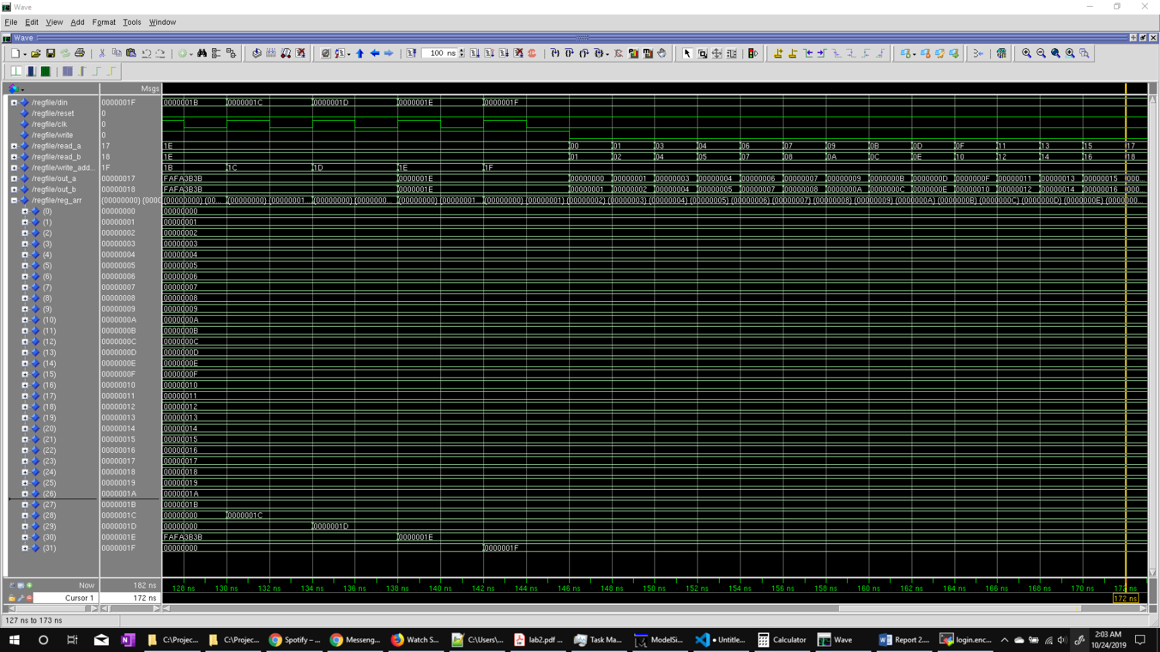

Figure Simulation of 126 to 172ns is shown in the figure. All the 32 registers are loaded with data at 32 clock rising edges. The read_a and read_b values are changed to see the proper output at the out ports.

* Precision log file

# Info: [9566]: Logging project transcript to file /nfs/home/s/sal_rahm/316/fpga_adv/lab1/lab1_impl_1/precision.log

# Info: [9566]: Logging suppressed messages transcript to file /nfs/home/s/sal_rahm/316/fpga_adv/lab1/lab1_impl_1/precision.log.suppressed

# Info: [9550]: Activated implementation lab1_impl_1 in project /nfs/home/s/sal_rahm/316/fpga_adv/lab1/lab1.psp.

new_project -name lab1 -folder /nfs/home/s/sal_rahm/316/fpga_adv/lab1 -createimpl_name lab1_impl_1

# COMMAND: add_input_file {../../32-bit-CPU/alu.vhd}

add_input_file {../../32-bit-CPU/alu.vhd}

# COMMAND: setup_design -manufacturer Xilinx -family "VIRTEX-II Pro" -part 2VP30ff896 -speed -7

# Info: [15298]: Setting up the design to use synthesis library "xcv2p.syn"

# Info: [575]: The global max fanout is currently set to 10000 for Xilinx - VIRTEX-II Pro.

# Info: [15324]: Setting Part to: "2VP30ff896".

# Info: [15325]: Setting Process to: "7".

# Info: [7512]: The place and route tool for current technology is ISE.

setup_design -manufacturer Xilinx -family "VIRTEX-II Pro" -part 2VP30ff896 -speed -7

# COMMAND: setup_design -frequency 100 -max_fanout=10000

# Info: [575]: The global max fanout is currently set to 10000 for Xilinx - VIRTEX-II Pro.

setup_design -frequency 100 -max_fanout=10000

# COMMAND: compile

# Info: [3022]: Reading file: /CMC/tools/mentor/precision/Mgc_home/pkgs/psr/techlibs/xcv2p.syn.

# Info: [634]: Loading library initialization file /CMC/tools/mentor/precision/Mgc_home/pkgs/psr/userware/xilinx_rename.tcl

# Info: XILINX

# Info: [40000]: vhdlorder, Release 2016a.7

# Info: [40000]: Files sorted successfully.

# Info: [40000]: hdl-analyze, Release RTLC-Precision 2016a.7

# Info: [42502]: Analyzing input file "/nfs/home/s/sal_rahm/316/fpga_adv/lab1/../../32-bit-CPU/alu.vhd" ...

# Error: [42996]: "/nfs/home/s/sal_rahm/316/fpga_adv/lab1/../../32-bit-CPU/alu.vhd", line 135: Illegal reference of signal - cannot elaborate statically

# Error: [40008]: HDL analysis failed.

compile

# COMMAND: exit -force

# Warning: [9526]: Discarded unsaved work in implementation lab1_impl_1.

# Info: [9565]: Appending project transcript to file /nfs/home/s/sal_rahm/316/fpga_adv/lab1/lab1_impl_1/precision.log

# Info: [9565]: Appending suppressed messages transcript to file /nfs/home/s/sal_rahm/316/fpga_adv/lab1/lab1_impl_1/precision.log.suppressed

# Info: [9550]: Activated implementation lab1_impl_1 in project /nfs/home/s/sal_rahm/316/fpga_adv/lab1/lab1.psp.

open_project /nfs/home/s/sal_rahm/316/fpga_adv/lab1/lab1.psp

# COMMAND: add_input_file {../../32-bit-CPU/alu.vhd}

add_input_file {../../32-bit-CPU/alu.vhd}

# COMMAND: setup_design -manufacturer Xilinx -family "VIRTEX-II Pro" -part 2VP30ff896 -speed -7

# Info: [15298]: Setting up the design to use synthesis library "xcv2p.syn"

# Info: [575]: The global max fanout is currently set to 10000 for Xilinx - VIRTEX-II Pro.

# Info: [15324]: Setting Part to: "2VP30ff896".

# Info: [15325]: Setting Process to: "7".

# Info: [7512]: The place and route tool for current technology is ISE.

setup_design -manufacturer Xilinx -family "VIRTEX-II Pro" -part 2VP30ff896 -speed -7

# COMMAND: setup_design -frequency 100 -max_fanout=10000

# Info: [575]: The global max fanout is currently set to 10000 for Xilinx - VIRTEX-II Pro.

setup_design -frequency 100 -max_fanout=10000

# COMMAND: compile

# Info: [3022]: Reading file: /CMC/tools/mentor/precision/Mgc_home/pkgs/psr/techlibs/xcv2p.syn.

# Info: [634]: Loading library initialization file /CMC/tools/mentor/precision/Mgc_home/pkgs/psr/userware/xilinx_rename.tcl

# Info: XILINX

# Info: [40000]: vhdlorder, Release 2016a.7

# Info: [40000]: Files sorted successfully.

# Info: [40000]: hdl-analyze, Release RTLC-Precision 2016a.7

# Info: [42502]: Analyzing input file "/nfs/home/s/sal_rahm/316/fpga_adv/lab1/../../32-bit-CPU/alu.vhd" ...

# Info: [659]: Top module of the design is set to: alu.

# Info: [657]: Current working directory: /nfs/home/s/sal_rahm/316/fpga_adv/lab1/lab1_impl_1.

# Info: [40000]: RTLC-Driver, Release RTLC-Precision 2016a.7

# Info: [40000]: Last compiled on Jun 2 2016 06:11:46

# Info: [44512]: Initializing...

# Info: [44504]: Partitioning design ....

# Info: [40000]: RTLCompiler, Release RTLC-Precision 2016a.7

# Info: [40000]: Last compiled on Jun 2 2016 06:47:43

# Info: [44512]: Initializing...

# Info: [44522]: Root Module work.alu(alu_architecture): Pre-processing...

# Info: [44523]: Root Module work.alu(alu_architecture): Compiling...

# Info: [44842]: Compilation successfully completed.

# Info: [44856]: Total lines of RTL compiled: 149.

# Info: [44835]: Total CPU time for compilation: 0.0 secs.

# Info: [44513]: Overall running time for compilation: 5.0 secs.

# Info: [657]: Current working directory: /nfs/home/s/sal_rahm/316/fpga_adv/lab1/lab1_impl_1.

# Info: [15330]: Doing rtl optimizations.

# Info: [660]: Finished compiling design.

compile

# COMMAND: synthesize

# Info: [657]: Current working directory: /nfs/home/s/sal_rahm/316/fpga_adv/lab1/lab1_impl_1.

# Info: [15002]: Optimizing design view:.work.alu.alu_architecture

# Info: [3027]: Writing file: /nfs/home/s/sal_rahm/316/fpga_adv/lab1/lab1_impl_1/alu.edf.

# Info: [3027]: Writing file: /nfs/home/s/sal_rahm/316/fpga_adv/lab1/lab1_impl_1/alu.ucf.

# Info: [660]: Finished synthesizing design.

# Info: [11019]: Total CPU time for synthesis: 0.9 s secs.

# Info: [11020]: Overall running time for synthesis: 1.2 s secs.

synthesize

# COMMAND: save_project

# Info: [9562]: Saved implementation lab1_impl_1 in project /nfs/home/s/sal_rahm/316/fpga_adv/lab1/lab1.psp.

save_project

* RTL schematic and Tech schematic

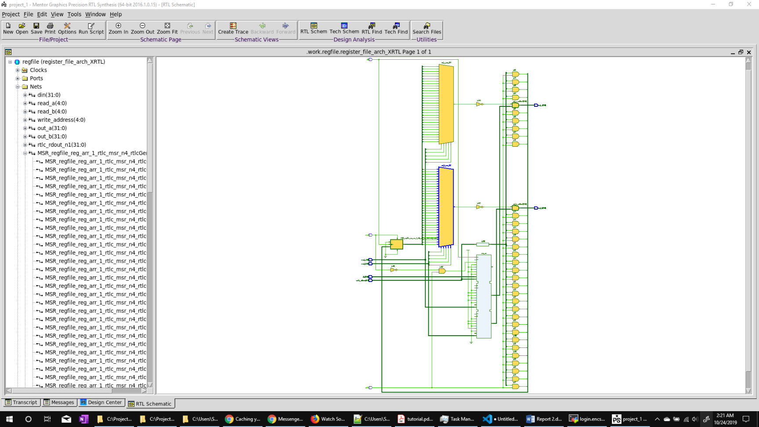

Figure RTL schematic of the VHDL code

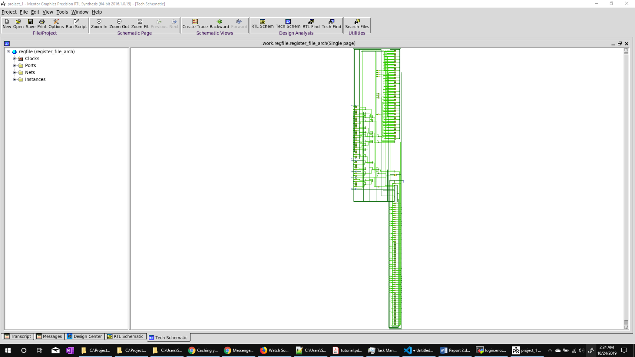

Figure Tech schematic of the synthesis

* ALU.UCF file

# Precision RTL Synthesis 64-bit 2016.1.0.15 (Production Release) Wed Jun 8 09:35:56 PDT 2016

CONFIG STEPPING="0";

NET out_a (0) LOC = T6;

NET out_a (1) LOC = V1;

NET out_a (2) LOC = R3;

NET out_a (3) LOC = R5;

NET out_a (4) LOC = T2;

NET out_a (5) LOC = P4;

NET out_a (6) LOC = R7;

NET out_a (7) LOC = P2;

* VHDL Code

-- 32 x 32 register file

-- two read ports, one write port with write enable

library IEEE;

use IEEE.std_logic_1164.all;

use IEEE.std_logic_unsigned.all;

entity regfile is

port(

din : in std_logic_vector(31 downto 0);

reset : in std_logic;

clk : in std_logic;

write : in std_logic;

read_a : in std_logic_vector(4 downto 0);

read_b : in std_logic_vector(4 downto 0);

write_address : in std_logic_vector(4 downto 0);

out_a : out std_logic_vector(31 downto 0);

out_b : out std_logic_vector(31 downto 0)

);

end regfile ;

architecture register_file_arch of regfile is

-- 32 registers in a register file, thus 0 to 31 in reg_arr

type register_array is array(0 to 31) of std_logic_vector(din'length-1 downto din'right);

signal reg_arr : register_array;

begin

read: process(read_a, read_b, reg_arr)

begin

-- converting std vector to integer - to find the appropriate register to access

out_a <= reg_arr(CONV_INTEGER(read_a));

out_b <= reg_arr(CONV_INTEGER(read_b));

end process;

reg_file_update: process(clk, reset)

begin

if(reset = '1') then

reg_arr <= (others => (others => '0'));

elsif(clk'event and clk = '1' and write = '1') then

reg_arr(CONV_INTEGER(write_address)) <= din;

end if;

end process;

end register_file_arch ;